Vanier College

Deliverable 3

  Client: Opeq, Simon

System Development Section 01

Team Orange:

Jiamin Yuan

Dinal Patel

Craig Justin Balibalos

Alihan Djamankulov

Ibrahim Awad

Submission Date:

Wednesday October 5, 2021

I, (Jiamin Yuan), student ID# (2055624), certify that I have contributed to this deliverable, (signature – this can be a scanned image, or an electronic signature).



I, (Dinal Patel), student ID# (2042827), certify that I have contributed to this deliverable, (signature – this can be a scanned image, or an electronic signature).



I, (Craig Justin Balibalos), student ID# (2069192), certify that I have contributed to this deliverable, (signature – this can be a scanned image, or an electronic signature).



I, (Alihan Djamankulov), student ID# (2033628), certify that I have contributed to this deliverable, (signature – this can be a scanned image, or an electronic signature).



I, (Ibrahim Awad), student ID# (2032818), certify that I have contributed to this deliverable, (signature – this can be a scanned image, or an electronic signature).



**Table of contents**

Statement ------------------------------------------------------ **4**

Executive Overview ------------------------------------------------------ **4**

Summary Desc. of Client ------------------------------------------------------ **4**

Business Problem ------------------------------------------------------ **4**

Narrative Description ------------------------------------------------------ **5**

Appendix 1 ------------------------------------------------------ **5**

Appendix 2 ------------------------------------------------------ **6**

Appendix 3 ------------------------------------------------------ **7-11**

Appendix 4 ------------------------------------------------------ **12**

Appendix 5 ------------------------------------------------------ **13**

**Previous Work Statement**

Our team will focus on creating the application from scratch using C# language. Some requirements for the application are that it must be downloadable on PC, and it must be able to connect to a web database. We will use the ideas that we learned from Application Development 1 in the previous semester. We will not use any previous code, but we will use the knowledge that we learned from before.

**Executive Overview**

The problem that the company OPEQ has is storing caller information on an excel sheet. They want us to make an application that will make it more efficient to store caller information. According to the excel template the client provided, and the application overview diagram created in the previous deliverable, we created a flowchart, a UML diagram, case templates, and a class diagram for this deliverable. This data will be used to build the database and software. For instance, the relationships between tables, the tasks that each interface needs, etc. We include a summary of the current information system in the narrative description. It covers the application’s functionality and operating flow.

**Summary description of client**

The client’s full name is Simon Provencher; he is a supervisor at a company named OPEQ, Dinal and Ibrahim’s former manager. He deals with computer components like hard drives, motherboards, RAM etc. The client is remarkably familiar with computers, so he is very skilled and has decent literacy, for example, he is quite familiar with Microsoft Office 365 apps like word, excel, etc. He is also familiar with databases as we used databases for items during the internship.

The business problem is that Simon wants a better way to fill out an excel sheet using an application. The application will help organise the data and make it easier to navigate. He wants to use an application because it will be clearer and more consistent to fill out rather than an excel sheet.

**Business problem**

The problem that our client told us is that they are having a tough time recording the information of the customers that call them. They use an excel sheet to record the information but it takes a while to do it so some information might get mixed up with the others or forgotten completely. The solution that our client proposed is to make a desktop application that will make recording customer information fast and easy and it will also make the viewing of the records more organized. We made a UML diagram, a Flowchart, a Class Diagram and some Use Case Templates to help better understand how the business problem is going to get resolved.

**Narrative description**

The database is modified by an employee who receives a call from a client with a problem. The boss or employee can later view a list of the past calls and problems to track progress.

The boss and employees have to track the client's product using a barcode to get all the information about the product. The barcode is used to scan then modify, add, and view the information of the client’s call.

The client’s problem may be fixed with a simple solution, or the company will have to give them a new product. When the company has to give a new product there will be a new barcode that will be used to store the information about the new product, with a return voucher

When it comes to the items involved in the company, they first need barcodes to add the item to the database, so to do that, there is a section for donations on the website and in there you must enter for example the computers serial number, model, etc. Which is how items are first added in the database in the first place. After that the item is in the database, in case there might be any mistake, the employee can always scan the barcode and edit whatever is not right like the serial number or model number. In case the bar code might have fallen off, the employee can always scan the serial number and reprint the barcode.

**Appendix 1**

**Flowchart:**

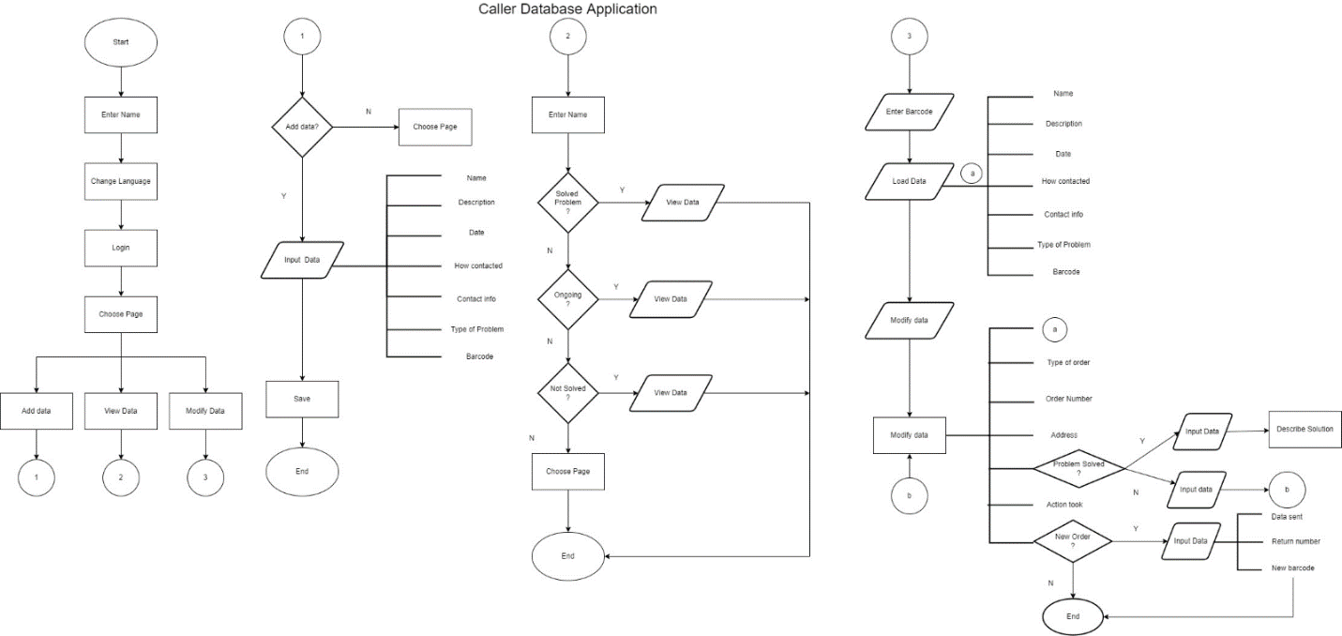

**Appendix 2**

**UML Diagram:**

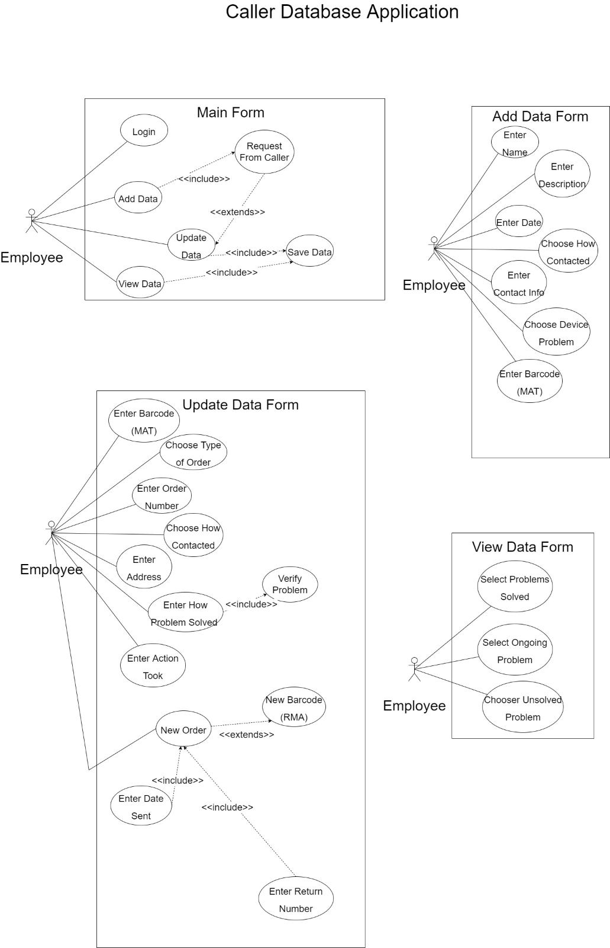

**Appendix 3**

**Case templates:**

|  |  |  |  |
| --- | --- | --- | --- |
| **Use Case ID** | OP-Login | | |
| **Use Case Name** | Login | | |
| **Created By:** | Djamankulov Alihan | **Last Updated By:** | N/A |
| **Date Created:** | 28/09/2022 | **Last Revision Date:** | N/A |
| **Actors:** | Employee (Primary) | | |
| **Description:** | This use case lets employee to login to the system | | |
| **Trigger:** | Employee pushes the login button | | |
| **Preconditions:** | * Employee starts the system application and lands on login page | | |
| **Post Conditions** | * Employee is logged in the system * Employee gets options to choose such as add data, view data, and update data in the database | | |
| **Normal Flow** | * Employee puts his name and logins to the system | | |
| **Alternative Flows** | N/A | | |
| **Exceptions:** | N/A | | |
| **Includes:** | OP-AddData, OP-ViewData, OP-UpdateData | | |
| **Frequency of Use:** | On demand | | |
| **Special Requirements:** | N/A | | |
| **Assumptions:** | Employee will login to the system | | |
| **Notes and Issues:** | N/A | | |

|  |  |  |  |
| --- | --- | --- | --- |
| **Use Case ID** | OP-RequestFromCaller | | |
| **Use Case Name** | Request from caller | | |
| **Created By:** | Djamankulov Alihan | **Last Updated By:** | N/A |
| **Date Created:** | 28/09/2022 | **Last Revision Date:** | N/A |
| **Actors:** | Employee (Primary),  Customers of OPEQ (Secondary) | | |
| **Description:** | This use case describes how OPEQ gets a request from a customer | | |
| **Trigger:** | Employee gets a call from a customer | | |
| **Preconditions:** | * Employee is at workplace waiting for calls | | |
| **Post Conditions (what happens after the whole process)** | * Employee has talked with a customer * Employee is going to put the information of the customer, or modify it | | |
| **Normal Flow (what happens during the process)** | * Employee gets a call from a customer * Employee talks with a customer * Customer accepts the service | | |
| **Alternative Flows** | N/A | | |
| **Exceptions:** | If customer denies getting the service, employee does not proceed to add the data | | |
| **Includes:** | OP-AddData, OP-ModifyData | | |
| **Frequency of Use:** | On demand | | |
| **Special Requirements:** | N/A | | |
| **Assumptions:** | Employee is at workplace waiting for calls | | |
| **Notes and Issues:** | N/A | | |

|  |  |  |  |
| --- | --- | --- | --- |
| **Use Case ID** | OP-AddData | | |
| **Use Case Name** | Add Data | | |
| **Created By:** | Djamankulov Alihan | **Last Updated By:** | N/A |
| **Date Created:** | 28/09/2022 | **Last Revision Date:** | N/A |
| **Actors:** | Employee (Primary),  Customers of OPEQ (Secondary) | | |
| **Description:** | This use case lets employee to add the data about the OPEQ customer | | |
| **Trigger:** | Employee gets a call from customer and pushes the button add data | | |
| **Preconditions:** | * Employee is logged in the system, has option to choose add page and has the customer’s information | | |
| **Post Conditions** | * Employee inputted all the data for customer * Employee saved the data | | |
| **Normal Flow** | * Employee pushes the add page button on login page * Employee is on the add page * Employee puts the data: * Employee enters name * Employee enters description * Employee enters date * Employee enters the contact information * Employee enters the type of contact used by customer * Employee chooses device problem * Employee enters barcode * Employee saves the data * Employee ends the session | | |
| **Alternative Flows** | N/A | | |
| **Exceptions:** | If customer denies getting the service, employee does not proceed to add the data and goes to choose other page or ends the session | | |
| **Includes:** | OP-RequestFromCaller, OP-SaveData | | |
| **Frequency of Use:** | On demand | | |
| **Special Requirements:** | N/A | | |
| **Assumptions:** | Employee is logged in the system and gets a request from a customer | | |
| **Notes and Issues:** | N/A | | |

|  |  |  |  |
| --- | --- | --- | --- |
| **Use Case ID** | OP-ViewData | | |
| **Use Case Name** | View Data | | |
| **Created By:** | Djamankulov Alihan | **Last Updated By:** | N/A |
| **Date Created:** | 28/09/2022 | **Last Revision Date:** | N/A |
| **Actors:** | Employee (Primary),  Customers of OPEQ (Secondary) | | |
| **Description:** | This use case lets employee to view the data about the OPEQ customer | | |
| **Trigger:** | Employee needs to see customer’s data, so employee pushes the button view data | | |
| **Preconditions:** | * Employee is logged in the system and has option to choose a view page | | |
| **Post Conditions** | * Employee saw all the customer’s information | | |
| **Normal Flow** | * Employee pushes the view page button on login page * Employee chooses problems (solved, ongoing, unresolved) * Employee sees all the data for a customer * Employee finishes the session | | |
| **Alternative Flows** | N/A | | |
| **Exceptions:** | N/A | | |
| **Includes:** | N/A | | |
| **Frequency of Use:** | On demand | | |
| **Special Requirements:** | N/A | | |
| **Assumptions:** | Employee is logged in the system | | |
| **Notes and Issues:** | N/A | | |

|  |  |  |  |
| --- | --- | --- | --- |
| **Use Case ID** | OP-UpdateData | | |
| **Use Case Name** | Update Data | | |
| **Created By:** | Djamankulov Alihan | **Last Updated By:** | N/A |
| **Date Created:** | 28/09/2022 | **Last Revision Date:** | N/A |
| **Actors:** | Employee (Primary),  Customers of OPEQ (Secondary) | | |
| **Description:** | This use case lets employee to update the data about the OPEQ customer | | |
| **Trigger:** | Employee gets a request from customer and pushes the button update data | | |
| **Preconditions:** | * Employee is logged in the system and has option to choose an update page | | |
| **Post Conditions** | * Employee updated customer’s data * Employee saved all the customer’s data | | |
| **Normal Flow** | * Employee gets a call from a customer about updating their data * Employee pushes the update page button on login page * Employee updates the customer’s data: * Employee enters barcode * Employee chooses type of order * Employee enters order number * Employee enters the type of contact used by customer * Employee enters customer’s address * Employee how problem should be solved * Employee enters action took for a problem * Employee makes new order * Employee finishes the session | | |
| **Alternative Flows** | N/A | | |
| **Exceptions:** | If customer denies to get the service, employee does not proceed to modify the data and goes to choose other page or ends the session | | |
| **Includes:** | OP-RequestFromCaller, | | |
| **Frequency of Use:** | On demand | | |
| **Special Requirements:** | N/A | | |
| **Assumptions:** | Employee is logged in the system | | |
| **Notes and Issues:** | N/A | | |

**Appendix 4**

**Class diagram:**

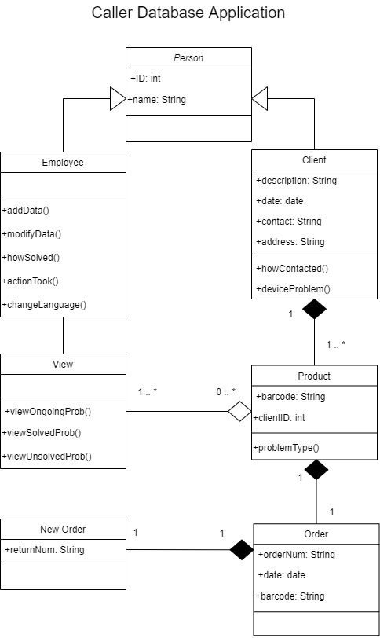

**Appendix 5**

**Client forms and documentation:**

